Sudheendra K

PGP.DSBA.OCT.B.22

Sudhi0404@gmail.com

Abstract

In the ever-evolving landscape of marketing and retail, understanding customer behavior and preferences is paramount for driving business growth and customer satisfaction. This analysis delves into two pivotal techniques: Recency, Frequency, Monetary (RFM) analysis and Market Basket analysis. These methodologies offer insightful perspectives into customer segmentation, buying patterns, and strategic decision-making.

Marketing and retail Analysis

PROJECT MRA

Table of Contents

Part A 2

Problem Statement: 2

Dataset 3

Agenda & Executive Summary of the data 3

Exploratory Analysis and Inferences 6

Customer Segmentation using RFM Analysis: 12

Assumptions: 12

Best Customers (Top 5): 14

Customers on the Verge of Churning (Top 5): 14

Lost Customers (Top 5): 15

Loyal Customers (Top 5): 15

Interpretation and Summary of the RFM Analysis 15

1. HHH Segment (High Recency, High Frequency, High Monetary): 15

2. HMH Segment (High Recency, Medium Frequency, High Monetary): 15

3. MMH Segment (Medium Recency, Medium Frequency, High Monetary): 15

4. MLL Segment (Medium Recency, Low Frequency, Low Monetary): 16

5. LLL Segment (Low Recency, Low Frequency, Low Monetary): 16

Conclusion 16

Part B 16

Problem Statement 16

Exploratory Analysis 16

Association Rules and Their Relevance: 18

In the case of the grocery store, association rules can help in several ways: 18

Threshold Values of Support and Confidence: 19

Associations Identified and Their Significance: 20

Understanding Support, Confidence, and Lift Values: 20

Support: 20

Confidence: 20

Lift: 21

Interpretation 21

Suggestions for Lucrative Combos with Discount Offers: 21

Combo: Breakfast Boost 21

Combo: Family Pasta Night 21

Combo: Snack Delight 21

Combo: Cleaning Essentials 22

Combo: Refreshing Beverage Pack 22

Combo: Weekend Indulgence 22

Additional Strategies: 22

Conclusion 22

# Part A

## Problem Statement:

An automobile parts manufacturing company has collected data on transactions for 3 years. They do not have any in-house data science team, thus they have hired you as their consultant. Your job is to use your data science skills to find the underlying buying patterns of the customers, provide the company with suitable insights about their customers, and recommend customized marketing strategies for different segments of customers.

## Dataset

Auto Sales Data: Sales_Data.xlsx

# Agenda & Executive Summary of the data

* From the below snippet we could observe a few rows and attributes of the Sales dataset

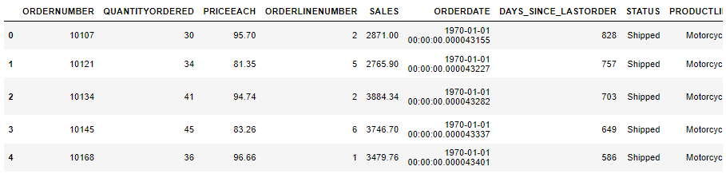

Snippet 1. 1 Head of the dataset

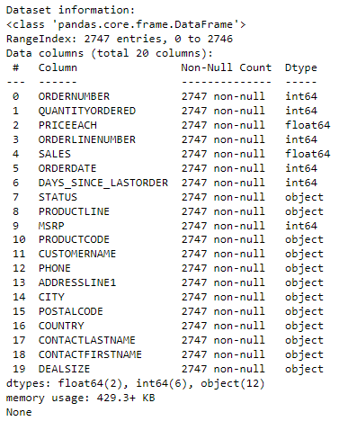

Snippet 1. 2 Information of the dataset

Here's a summary of the key details:

* Number of Entries: 2747
* Columns: 20
* Data Types: The dataset contains attributes of three main types:
* Numerical: There are 8 numerical attributes, including integer and float types. These attributes can be used for quantitative analysis and calculations.
* Categorical: There are 12 categorical attributes, represented as objects. These attributes represent categories or labels and may require encoding or transformation for analysis.
* String/Object: The STATUS, PRODUCTLINE, PRODUCTCODE, CUSTOMERNAME, PHONE, ADDRESSLINE1, CITY, POSTALCODE, COUNTRY, CONTACTLASTNAME, CONTACTFIRSTNAME, and DEALSIZE attributes contain textual information.
* Missing Data: The dataset appears to have no missing values, as indicated by the "Non-Null Count" for each attribute.

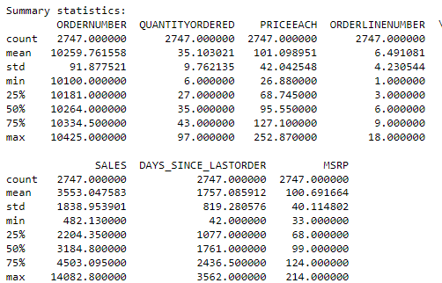

Snippet 1. 3 Statistical Summary of the Numerical Attributes

* The ORDERNUMBER ranges from 10100 to 10425.
* The QUANTITYORDERED ranges from 6 to 97.
* PRICEEACH ranges from 26.88 to 252.87.
* The mean price per item is approximately 101.10, with a standard deviation of 42.04.
* SALES ranges from 482.13 to 14082.80.
* The mean sales amount is approximately 3553.05, with a standard deviation of 1838.95.
* There are some higher sales values that might be considered as potential outliers.
* DAYS_SINCE_LASTORDER ranges from 42 to 3562.
* The mean days since the last order is approximately 1757.09, with a standard deviation of 819.28.
* There are no apparent outliers based on the summary statistics.
* MSRP (Manufacturer's Suggested Retail Price) ranges from 33 to 214.
* The mean MSRP is approximately 100.69, with a standard deviation of 40.11.
* The data appears to be normally distributed, with no extreme outliers.

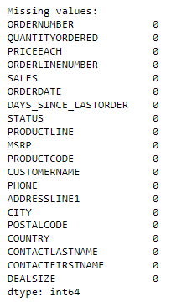

Snippet 1. 4 Missing Values

* The data doesn’t have any missing values

# Exploratory Analysis and Inferences

* Univariate, Bivariate, and multivariate analysis using data visualization (Weekly, Monthly, Quarterly, Yearly Trends in Sales and Sales Across different Categories of different features in the given data) -> Summarise the inferences

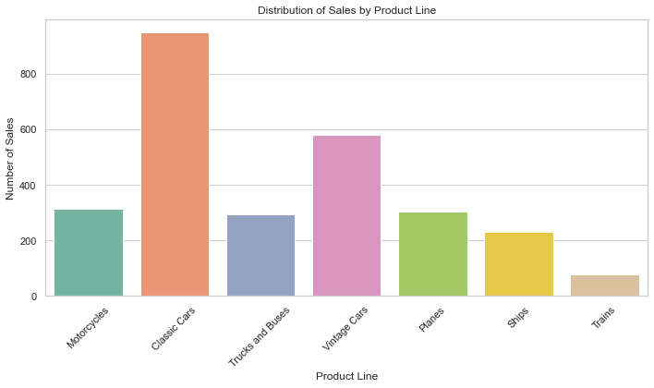

Figure 1. 1 Distribution of Sales by Product Line

* Distribution of Sales by Product classic cars has the highest sales among the total 7 product lines and lowest being Trains

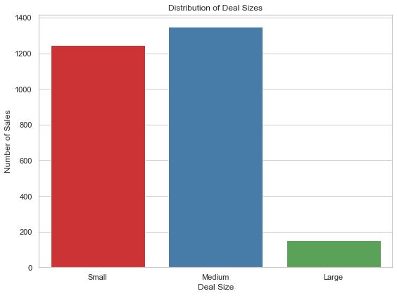

Figure 1. 2 Distribution of Deal Sizes

* Distribution of Deal Sizes, here we could see that medium sized category stands on top of small and large type.

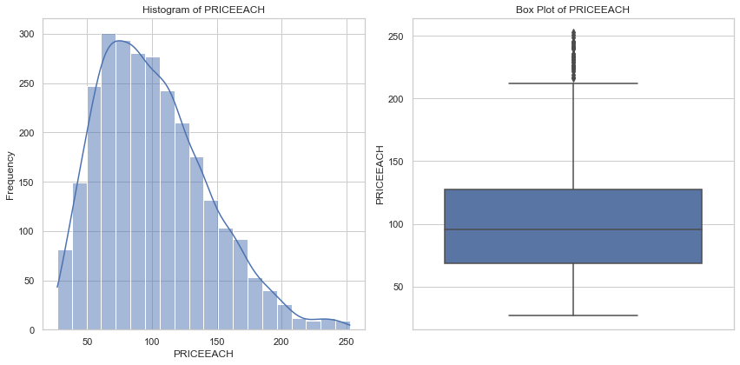

Figure 1. 3 Univariate Analysis of PriceEach

* PRICEEACH ranges from 26.88 to 252.87.
* The mean price per item is approximately 101.10, with a standard deviation of 42.04.
* There are apparent outliers based on the boxplot of this attribute.

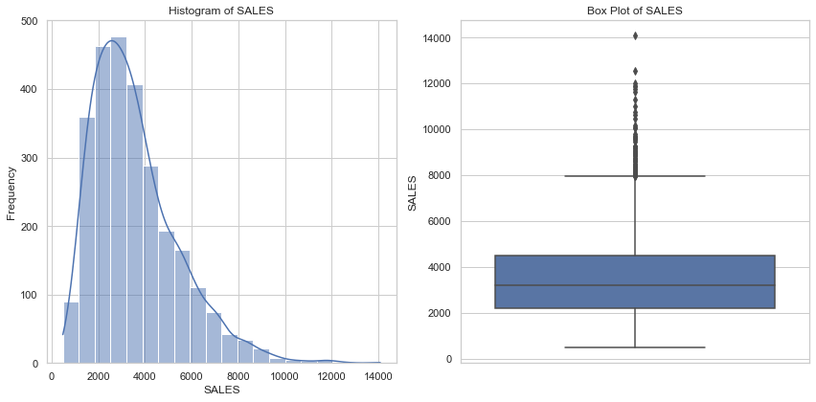

Figure 1. 4 Univariate Analysis of Sales

* SALES ranges from 482.13 to 14082.80.
* The mean sales amount is approximately 3553.05, with a standard deviation of 1838.95.
* There are some higher sales values that might be considered as potential outliers.

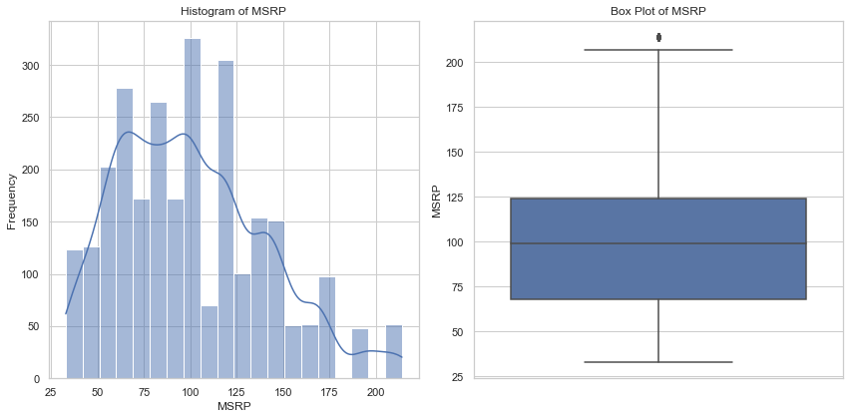

Figure 1. 5 Univariate Analysis of MSRP

* MSRP (Manufacturer's Suggested Retail Price) ranges from 33 to 214.
* The mean MSRP is approximately 100.69, with a standard deviation of 40.11.
* The data appears to be not normally distributed, with no extreme outliers.

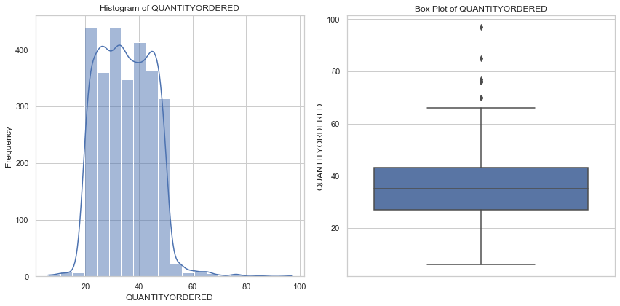

Figure 1. 6 Univariate Analysis of Quantity Order

* The QUANTITYORDERED ranges from 6 to 97.
* The average quantity ordered is around 35.10, with a standard deviation of 9.76.
* The data appears to be normally distributed, with outliers.

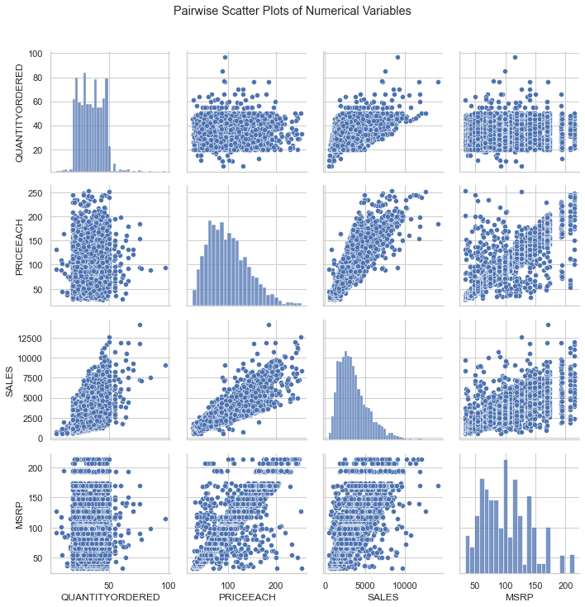

Figure 1. 7 Pair wise Scatter Plots of Numerical Variables

* The PRICEEACH attribute has a moderate positive correlation (0.78) with SALES, indicating that higher prices are associated with higher sales.
* The QUANTITYORDERED attribute has a moderate positive correlation (0.55) with SALES, implying that higher quantities ordered are linked to higher sales.

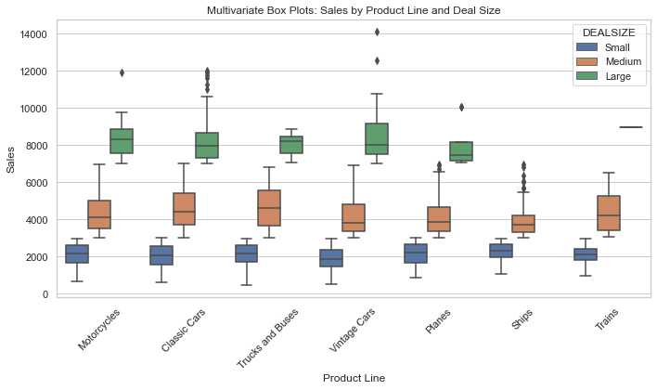

Figure 1. 8 Multivariate Analysis: Sales by Product Line and Deal Size

# Customer Segmentation using RFM Analysis:

RFM stands for Recency, Frequency, and Monetary. It's a technique used to segment customers based on their purchasing behaviour. Each letter of RFM represents a key parameter:

* Recency (R): How recently a customer made a purchase.
* Frequency (F): How often a customer makes a purchase.
* Monetary (M): How much money a customer spends on purchases.

The RFM analysis involves assigning a score to each customer for each parameter, typically on a scale of 1 to 5 (with 5 being the highest). Then, customers are segmented based on these scores to create groups with similar behaviours. Common segmentation schemes include "Best Customers," "Loyal Customers," "Churn Risk," and "Low-Value Customers."

# Assumptions:

* Recency is measured from the last transaction date to the current date.
* Frequency is calculated as the total number of transactions for a customer.
* Monetary is calculated as the total amount spent by a customer.

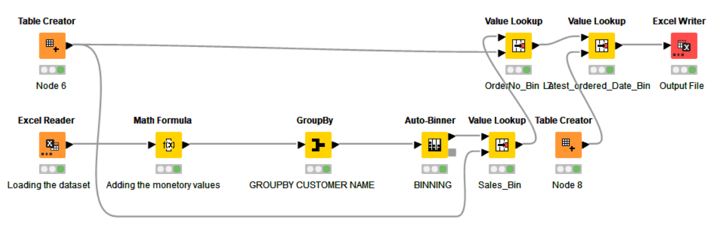

Figure 1. 9 KNIME Workflow Image

|  |  |  |  |  |  |  |  |  |
| --- | --- | --- | --- | --- | --- | --- | --- | --- |
| **CUSTOMERNAME** | **QUANTITYORDERED** | **PRICEEACH** | **COUNTRY** | **SALES** | **DAYS_SINCE_LASTORDER** | **R_LABEL** | **F_LABEL** | **M_LABEL** |
| AV Stores, Co. | 34.8627 | 91.085 | UK | 157807.8 | 421 | H | M | M |
| Alpha Cognac | 34.35 | 101.16 | France | 70488.44 | 675 | L | M | L |
| Amica Models & Co. | 32.4231 | 110.85 | Italy | 94117.26 | 328 | M | L | M |
| Anna's Decorations, Ltd | 31.9348 | 106.42 | Australia | 153996.1 | 131 | H | H | H |
| Atelier graphique | 38.5714 | 92.239 | France | 24179.96 | 312 | L | M | M |
| Australian Collectables, Ltd | 30.6522 | 90.042 | Australia | 64591.46 | 1018 | L | M | L |
| Australian Collectors, Co. | 35.0182 | 104.59 | Australia | 200995.4 | 229 | H | H | H |
| Australian Gift Network, Co | 36.3333 | 110.55 | Australia | 59469.12 | 190 | L | M | H |
| Auto Assoc. & Cie. | 35.3889 | 99.488 | France | 64834.32 | 275 | L | L | M |
| Auto Canal Petit | 37.0741 | 94.255 | France | 93170.66 | 127 | M | M | H |
| Auto-Moto Classics Inc. | 35.875 | 92.8 | USA | 26479.26 | 1353 | L | M | L |

Table 1 Results in the output head of the data

* The final output of the RFM analysis is as above and the pivotal table for the segmentation could be found below.

|  |  |  |  |  |  |
| --- | --- | --- | --- | --- | --- |
|  |  |  | **Monetary** | | |
| **Status** | **Recency** | **Frequency** | **H** | **M** | **L** |
| **Active** | **H** | **H** | **11** | **1** | **0** |
| **M** | **1** | **9** | **1** |
| **L** | **0** | **0** | **0** |
| **At Risk** | **M** | **H** | **3** | **3** | **0** |
| **M** | **5** | **11** | **1** |
| **L** | **0** | **11** | **10** |
| **Churn** | **L** | **H** | **1** | **1** | **1** |
| **M** | **1** | **6** | **5** |
| **L** | **0** | **2** | **5** |

Table 2 Customer Segmentation with RFM Analysis

## Best Customers (Top 5):

* **Anna's Decorations, Ltd** - High Monetary (M_LABEL), High Frequency (F_LABEL), High Recency (R_LABEL)
* **Australian Collectors, Co.** - High Monetary (M_LABEL), High Frequency (F_LABEL), High Recency (R_LABEL)
* **Euro Shopping Channel** - High Monetary (M_LABEL), High Frequency (F_LABEL), High Recency (R_LABEL)
* **Mini Gifts Distributors Ltd**. - High Monetary (M_LABEL), High Frequency (F_LABEL), High Recency (R_LABEL)
* **Rovelli Gifts** - High Monetary (M_LABEL), High Frequency (F_LABEL), High Recency (R_LABEL)

## Customers on the Verge of Churning (Top 5):

* **Clover Collections, Co.** - Low Monetary (M_LABEL), Low Frequency (F_LABEL), Moderate Recency (R_LABEL)
* **Gift Ideas Corp.** - Low Monetary (M_LABEL), Low Frequency (F_LABEL), Low Recency (R_LABEL)
* **Muscle Machine Inc** - High Monetary (M_LABEL), High Frequency (F_LABEL), Moderate Recency (R_LABEL)
* **Quebec Home Shopping Network** - High Monetary (M_LABEL), High Frequency (F_LABEL), Low Recency (R_LABEL)
* **Signal Collectibles Ltd.** - Low Monetary (M_LABEL), Low Frequency (F_LABEL), Low Recency (R_LABEL)

## Lost Customers (Top 5):

* **AV Stores, Co.** - High Monetary (M_LABEL), Low Frequency (F_LABEL), High Recency (R_LABEL)
* **Auto Assoc. & Cie**. - Low Monetary (M_LABEL), Low Frequency (F_LABEL), Low Recency (R_LABEL)
* **Herkku Gifts** - High Monetary (M_LABEL), High Frequency (F_LABEL), Moderate Recency (R_LABEL)
* **Super Scale Inc.** - Low Monetary (M_LABEL), Low Frequency (F_LABEL), Moderate Recency (R_LABEL)
* **Tokyo Collectables, Ltd** - High Monetary (M_LABEL), High Frequency (F_LABEL), Moderate Recency (R_LABEL)

## Loyal Customers (Top 5):

* **Oulu Toy Supplies, Inc.** - High Monetary (M_LABEL), High Frequency (F_LABEL), Moderate Recency (R_LABEL)
* **Signal Gift Stores** - Moderate Monetary (M_LABEL), Moderate Frequency (F_LABEL), Moderate Recency (R_LABEL)
* **Tekni Collectables Inc.** - High Monetary (M_LABEL), High Frequency (F_LABEL), High Recency (R_LABEL)
* **The Sharp Gifts Warehouse** - High Monetary (M_LABEL), High Frequency (F_LABEL), High Recency (R_LABEL)
* **Vitachrome Inc**. - High Monetary (M_LABEL), High Frequency (F_LABEL), High Recency (R_LABEL)

# 

# Interpretation and Summary of the RFM Analysis

## 1. HHH Segment (High Recency, High Frequency, High Monetary):

* There are 11 customers who have recently made frequent purchases with high monetary spending.
* These are your most valuable and active customers.

## 2. HMH Segment (High Recency, Medium Frequency, High Monetary):

* There is 1 customer who has recently made moderate-frequency purchases with high monetary spending.
* This customer might be someone who has made several high-value purchases recently but is not as frequent as the HHH segment.

## 3. MMH Segment (Medium Recency, Medium Frequency, High Monetary):

* There are 11 customers who have made purchases with medium frequency and high monetary spending.
* These customers might be consistently spending good amounts.

## 4. MLL Segment (Medium Recency, Low Frequency, Low Monetary):

* There are 10 customers who have made purchases with medium recency and low frequency and monetary spending.
* These customers might have made a few small purchases and haven't returned recently.

## 5. LLL Segment (Low Recency, Low Frequency, Low Monetary):

* There are 5 customers who have low recency, low frequency, and low monetary spending.
* These are potentially inactive customers.

# Conclusion

* These inferences provide insights into different customer segments based on their recency, frequency, and monetary scores.
* Each segment has unique characteristics, allowing the store to tailor marketing strategies.
* For example,
  + loyal customers might be targeted with loyalty rewards,
  + at-risk customers could receive special offers,
  + churn-risk customers could be engaged with retention campaigns.

--------------------------------------------------------------------------------------------------------------------------------------

# Part B

## Problem Statement

A grocery store shared the transactional data with you. Your job is to conduct a thorough analysis of Point of Sale (POS) data, identify the most commonly occurring sets of items in the customer orders, and provide recommendations through which a grocery store can increase its revenue by popular combo offers & discounts for customers.

Dataset

Grocery Store Data: dataset_group.csv.

# Exploratory Analysis

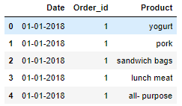

Snippet 2. 1 Head of the Dataset

* Above, you could see the head of the dataset

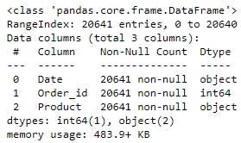

Snippet 2. 2 Information of the dataset

* We have total 3 columns with no null values
* There are two objective and integer type of attributes

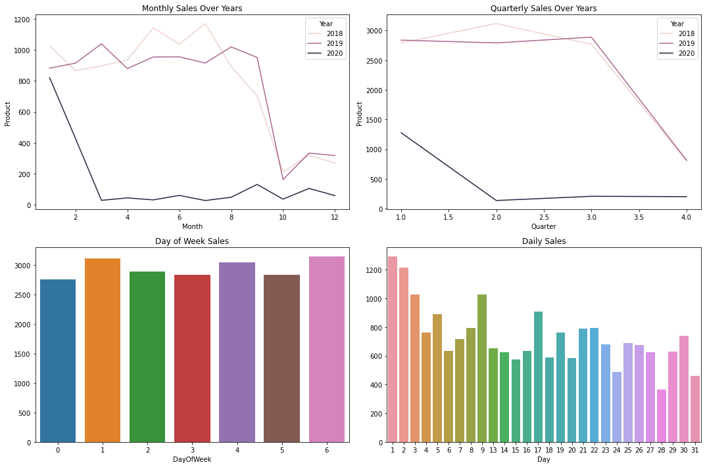

Figure 2. 1 Daily, Weekly, Quarterly and Yearly Sales Visualization

* The Monthly sales over years doesn’t show any regular trend or seasonality
* In 2020, the monthly sales were the lowest compared to 2018-19
* Monday and Saturday shall have the highest sales over the days
* Every month’s starting days would have the higher sales and gradually decreases when see at the end of the month

# Association Rules and Their Relevance:

* Association rules are a fundamental concept in data mining and analytics, commonly used in Market Basket Analysis.
* They reveal interesting relationships and patterns within large datasets by identifying co-occurring items in transactions.
* In the context of a grocery store's transactional data, association rules can provide insights into how different products are often purchased together.
* This information is invaluable for optimizing product placement, devising strategic cross-promotions, and enhancing customer experience.

## In the case of the grocery store, association rules can help in several ways:

* Product Bundling: Identifying items frequently purchased together can lead to bundling products into combo offers, enhancing customer value and boosting sales.
* Store Layout: Placing co-occurring products near each other can increase convenience and encourage additional purchases.
* Targeted Marketing: Leveraging associations can facilitate targeted marketing campaigns to specific customer segments.
* Inventory Management: Understanding product relationships aids in efficient stock management and supply chain optimization.

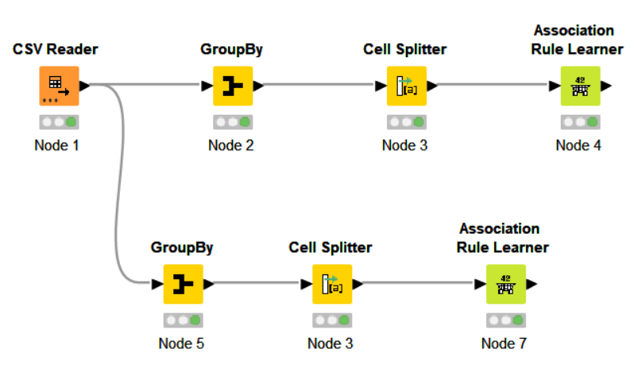

Figure 2. 2 KNIME workflow Image

# Threshold Values of Support and Confidence:

* Support and confidence are critical parameters in association rule analysis. They define the significance of the discovered patterns:
* Support: These measures how frequently a set of items appears in the dataset. A higher support value implies that the rule is more common. A low support threshold might lead to rules that are too specific, while a high threshold might miss interesting associations.
* Confidence: This quantifies how often the consequent (right-hand side) of the rule occurs when the antecedent (left-hand side) is present. A high confidence suggests a strong association. Too low a confidence might lead to too many false-positive associations.
* Selecting appropriate threshold values involves a trade-off between the number of discovered rules and their significance. It's often a trial-and-error process. Start with higher thresholds and gradually lower them until you achieve a balance between relevant rules and manageable results.
* In the KNIME workflow, you can adjust these threshold values based on the nature of the data and the goals of your analysis. Iterative experimentation can help you identify the thresholds that provide the most valuable insights.

# Associations Identified and Their Significance:

* Below is the tabular representation of the identified associations along with their corresponding support, confidence, and lift values:

|  |  |  |  |  |  |
| --- | --- | --- | --- | --- | --- |
| **Support** | **Confidence** | **Lift** | **Consequent** | **Implies** | **Items** |
| 0.050 | 0.640 | 1.700 | juice | <--- | [yogurt, toilet paper, aluminium foil] |
| 0.050 | 0.620 | 1.645 | juice | <--- | [yogurt, poultry, aluminium foil] |
| 0.050 | 0.613 | 1.616 | coffee/tea | <--- | [yogurt, cheeses, cereals] |
| 0.050 | 0.600 | 1.424 | poultry | <--- | [dishwashing liquid/detergent, laundry detergent, mixes] |
| 0.051 | 0.630 | 1.678 | mixes | <--- | [yogurt, poultry, aluminium foil] |
| 0.051 | 0.611 | 1.660 | sandwich bags | <--- | [cheeses, bagels, cereals] |
| 0.051 | 0.674 | 1.726 | cheeses | <--- | [bagels, cereals, sandwich bags] |
| 0.051 | 0.617 | 1.558 | cereals | <--- | [cheeses, bagels, sandwich bags] |
| 0.051 | 0.630 | 1.621 | dinner rolls | <--- | [spaghetti sauce, poultry, cereals] |
| 0.051 | 0.637 | 1.512 | poultry | <--- | [dinner rolls, spaghetti sauce, cereals] |
| 0.051 | 0.604 | 1.589 | milk | <--- | [poultry, laundry detergent, cereals] |
| 0.052 | 0.628 | 1.610 | eggs | <--- | [dinner rolls, poultry, soda] |
| 0.052 | 0.641 | 1.649 | dinner rolls | <--- | [spaghetti sauce, poultry, ice cream] |
| 0.052 | 0.686 | 1.628 | poultry | <--- | [dinner rolls, spaghetti sauce, ice cream] |
| 0.052 | 0.628 | 1.614 | dinner rolls | <--- | [spaghetti sauce, poultry, juice] |
| 0.052 | 0.602 | 1.429 | poultry | <--- | [dinner rolls, spaghetti sauce, juice] |
| 0.052 | 0.634 | 1.627 | eggs | <--- | [paper towels, dinner rolls, pasta] |
| 0.052 | 0.602 | 1.621 | pasta | <--- | [paper towels, eggs, dinner rolls] |
| 0.054 | 0.642 | 1.651 | dinner rolls | <--- | [spaghetti sauce, poultry, laundry detergent] |
| 0.054 | 0.656 | 1.556 | poultry | <--- | [dinner rolls, spaghetti sauce, laundry detergent] |
| 0.055 | 0.624 | 1.565 | ice cream | <--- | [paper towels, eggs, pasta] |
| 0.055 | 0.630 | 1.616 | eggs | <--- | [paper towels, ice cream, pasta] |
| 0.055 | 0.643 | 1.731 | pasta | <--- | [paper towels, eggs, ice cream] |
| 0.055 | 0.649 | 1.791 | paper towels | <--- | [eggs, ice cream, pasta] |

# Understanding Support, Confidence, and Lift Values:

## Support:

* Support indicates the frequency of an itemset in the dataset. For example, a support of 0.050 means that the itemset appears in approximately 5% of all transactions.
* Higher support values imply that the association is relatively common.

## Confidence:

* Confidence measures how often the consequent occurs when the antecedent is present. For instance, a confidence of 0.640 means that juice is purchased along with the other items in about 64% of the cases where those items are present.
* Higher confidence values imply a stronger association between the antecedent and the consequent.

## Lift:

* Lift quantifies how much more likely it is that the two items will be bought together compared to if they were bought independently. Lift values greater than 1 suggest a positive association between the items.
* A lift of 1 implies independence, while a lift greater than 1 implies a positive relationship.

# Interpretation

* For instance, the association rule "juice <--- [yogurt, toilet paper, aluminium foil]" has a support of 0.050, suggesting that this combination is present in 5% of transactions.
* The confidence value of 0.640 indicates that juice is purchased along with the other items in about 64% of cases where yogurt, toilet paper, and aluminium foil are purchased.
* A lift of 1.700 suggests that the purchase of juice is 1.7 times more likely when yogurt, toilet paper, and aluminium foil are purchased together than when they are bought independently.

# Suggestions for Lucrative Combos with Discount Offers:

Based on the associations identified through the Association Rule analysis, we can recommend the following potential combos with lucrative offers for the grocery store. These offers are designed to capitalize on the relationships between products and encourage customers to make additional purchases, ultimately increasing revenue.

## Combo: Breakfast Boost

* Offer: Buy a pack of yogurt, a box of cereal, and a carton of milk together at a discounted price.
* Rationale: The association rules show strong connections between yogurt, cereals, and milk. By bundling these items, customers are more likely to make a complete breakfast purchase.

## Combo: Family Pasta Night

* Offer: Purchase a jar of spaghetti sauce, a pack of pasta, and a poultry product to get a special discount.
* Rationale: The analysis reveals associations between spaghetti sauce, poultry, and pasta. Offering a combo deal for a family pasta night can entice customers to buy all the necessary components.

## Combo: Snack Delight

* Offer: Combine cheeses, bagels, and sandwich bags in a single purchase for a reduced price.
* Rationale: The strong associations between cheeses, bagels, and sandwich bags suggest that customers often buy these items together. Providing them as a combo can enhance convenience and save money for the shoppers.

## Combo: Cleaning Essentials

* Offer: Bundle dishwashing liquid/detergent, laundry detergent, and cleaning mixes at a special offer price.
* Rationale: The association rule linking these cleaning items together can prompt customers to stock up on their household cleaning essentials.

## Combo: Refreshing Beverage Pack

* Offer: Purchase juice, coffee/tea, and soda together with a discount.
* Rationale: The associations between these beverages indicate potential for cross-promotions, targeting customers who enjoy a variety of drinks.

## Combo: Weekend Indulgence

* Offer: Buy a variety of products like ice cream, dinner rolls, and other treats as a weekend package at a lower cost.
* Rationale: Combining indulgent items associated with weekend enjoyment can drive increased sales, especially during leisure days.

# Additional Strategies:

* "Buy Two, Get One Free" Deals: Implementing "buy two, get one free" or similar promotions on products that have strong associations can incentivize customers to purchase more and capitalize on the products' relationships.
* Promotion Visibility**:** Display products in these combos together, either physically in-store or digitally in an online platform, to remind customers of the enticing deals.
* Loyalty Programs**:** Introduce loyalty programs that offer exclusive discounts and rewards to customers who consistently purchase products from specific combos.
* Limited-Time Offers**:** Creating a sense of urgency with limited-time offers can encourage customers to make quicker purchasing decisions.

# Conclusion

* Remember that the success of these offers lies in effective communication, clear value propositions, and aligning the combos with customer preferences.
* Regularly analysing sales data and customer feedback will allow for fine-tuning these strategies over time.